Concept meeting

Introduction

Goals
- Pass maintenance testing estimating grunt work off to lead techs and project managers with estimators serving as review point before being sent to the customer.
  - Review process? It's already kind of in ampOS.
  - Acceptance projects will stay with the estimating team for now.

Ideas:
- Process. Estimating sheet follows a start to finish (linear) process so that you are not bouncing around on the estimate sheet. It feels less like a spreadsheet and more like filing out a form.
- Presets. Have a list of reference men/hours for common equipment types. Have these values populate from a table and then be adjustable within each estimate (changes within an estimate would not change the reference table). This has already been demonstrated outside of ampOS in some of the old Excel spreadsheets we have messed with.
  - Would require a global reference sheet only adjustable from the estimating presets tab within the opportunities dashboard.
  - In the scope page, add the ability to add equipment to the scope section by type of equipment then have a size section to enter in equipment sizing. Then ampOS will automatically pull the labor hours per equipment from the database in reference to preset thresholds.
  - Have the ability to set “Sections” in SOV & NON-SOV tables of scope page to break out by building/section.
- Notes. Side reference notes for the entire estimating sheet. Content would change based on what is selected.
  - Content for what is selected would need to be changeable from the estimating presets tab within the opportunities dashboard.
- Travel. Need to make travel simpler & also more capable
  - Specify length of outage or # of men at the start or after scope and before travel?
  - Needs to be able to handle trips from multiple locations to a single job location
  - Need to pull travel labor hours out of travel expense and into labor hour calculations (to make sure they get charged at the correct rate).

Scope Table Idea
SOV Scope

Building 1
Switchboard: Size<1600A>: Name<...>:Quantity<1>
- Insulated Case Breaker Primary Injection: Quantity: Size:
- Molded Case Breaker Primary Injection: Quantity: Size:
- Relays
- Control Power Transformer
- Potential Transformer (3ph set)
- Current Transformer (3ph set)

Panelboard
- Bus testing
- Branch breaker testing
- Main breaker testing

Transformer
- Transformer testing & report
- Oil sample labor & management

Building 2…
Switchboard: Size<1600A>: Name<...>:Quantity<1>
- Insulated Case Breaker Primary Injection: Quantity: Size:
- Molded Case Breaker Primary Injection: Quantity: Size:
- Relays
- Control Power Transformer
- Potential Transformer (3ph set)
- Current Transformer (3ph set)

Panelboard
- Bus testing
- Branch breaker testing
- Main breaker testing

Transformer
- Transformer testing & report
- Oil sample labor & management

Non SOV Table Idea

Same principle as SOV Scope.

Travel Table Idea

Same principle as SOV Scope.

Pricing Table Idea

Same principle as SOV Scope. It would resemble what is actually going on the letter proposal.

This process should enhance the feeling that you are constructing a proposal and not a spreadsheet that gets converted to a proposal.

Dividing Estimating into sub pages with forced process (no skip)
This would eliminate the “tabs” for each estimate.
All “estimates” would have to be done concurrently OR you would have to only proceed if some of the required fields were not populated. If there is one completed estimate “track” then the estimator should be able to create a letter proposal with only that one estimate “track”.

- Job Details (Project Overview outside estimate)
- SOV Page
  - Like current SOV table
  - At the bottom of the page, specify:
    - SOV hours, number of men, hours per day, calculated days onsite.

- Non-SOV Page
  - Like current NON-SOV Table

- Travel Page
  - Need to improve visuals here.
- Pricing Page
  - List SOV hours, NON-SOV Hours, Travel Hours (not changeable from here)
  - Delegate RT, OT, DT here
  - Pricing information & variables (like we currently have).
  - Generated SOV for each estimate.
- Summary Page

Questions we need to confirm:
- Would we want to supplement the current estimating process or completely change the existing set-up?
  - Suspected answer: Start separate with the intention or permanently replacing.
- Would we want this to be specifically for maintenance only or for acceptance as well since we are wanting to keep acceptance with the estimating team?
  - Suspected answer: goal is to have maintenance & acceptance estimated in the same process

Consequences
- A forced process will likely reduce mistakes and improve overall estimate accuracy while making the barrier to entry lower. However, this will cost us more time & effort on behalf of the existing and new estimators on the team. Required fields will most likely need to be implemented in order to maintain this forced process.
- Estimates will have to have their due dates pushed earlier internally to allow for the review process to occur.
- Documentation of scope and conversations with customers and scope assumptions will have to be collected and provided for proper review to occur.

Whiteboard notes to explain estimating “Track”
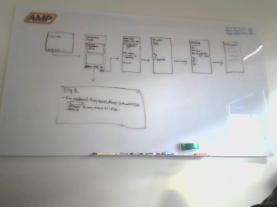

SOV & NON-SOV

Link to Preset Idea

- Use the “Link to library” idea for each SOV Item from table in estimating presets

- Use the “Link to library” idea for each Non-SOV item that will be tied to SOV hours. Also set in estimating pre-sets but will change depending on the SOV hours in that particular estimate.

SOV & NON-SOV Pages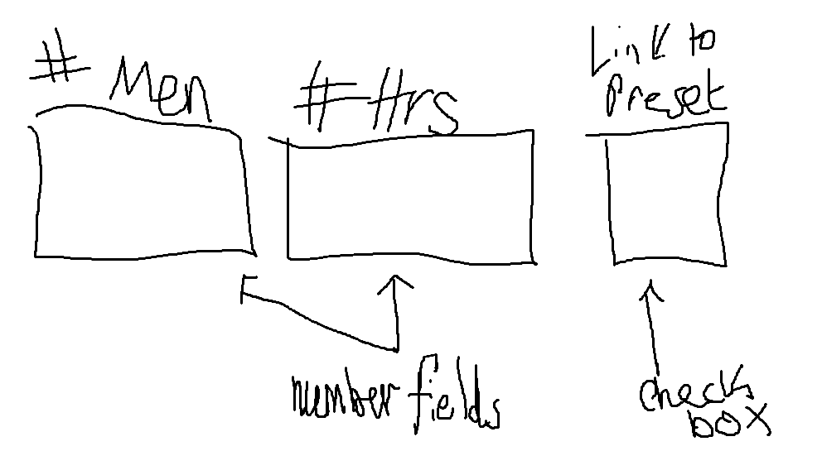
Figure: “Link to Library” idea

SOV Scope Page

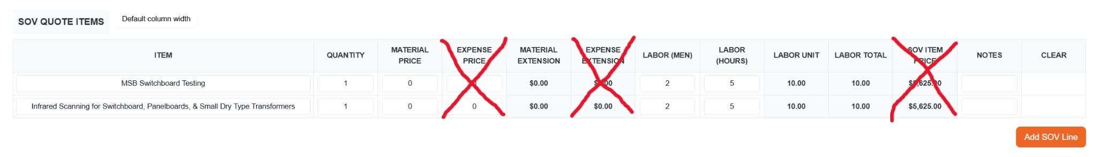
Modifications
- Remove the expense columns. We really don’t use these and would reduce the clutter. Any expenses that would need to be inputted in the expense column would be able to be input to the material column.
- We would like to remove the SOV Item price column from this table and relocate it into its own table near the end of the proposal. The schedule of values (what SOV stands for) that we would want to deliver to our customer will have the ITEM, the QUANTITY, the SOV ITEM PRICE, and a new column: the “SOV TOTAL PRICE” which will be the SOV ITEM Price multiplied by the QUANTITY.
- The material column should remain visible and have the ability to be edited in the estimating preset equipment details – i.e. we should be able to specify that oil filled transformers will have a material cost (oil test) of $200 whenever someone adds an oil filled transformer to the scope of work. The material value should also be locked unless the row is unlinked from the presets table.

Non-SOV Scope Page
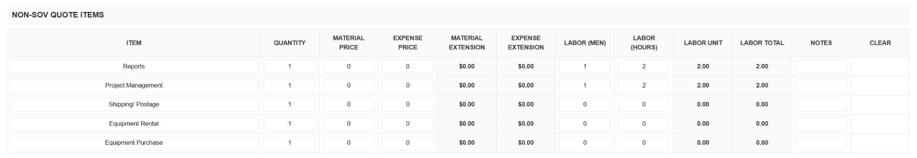
Modifications
- Remove the expense columns. We really don’t use these and would reduce the clutter. Any expenses that would need to be inputted in the expense column would be able to be input to the material column.
- Reports and Project Management men should always both be defaulted to 1 man and set to 5% of the total SOV labour hours, there should still be the ability to edit in the rare case of edits, however it should always just be defaulted.

Travel Page → See the document tab to the left for the travel page

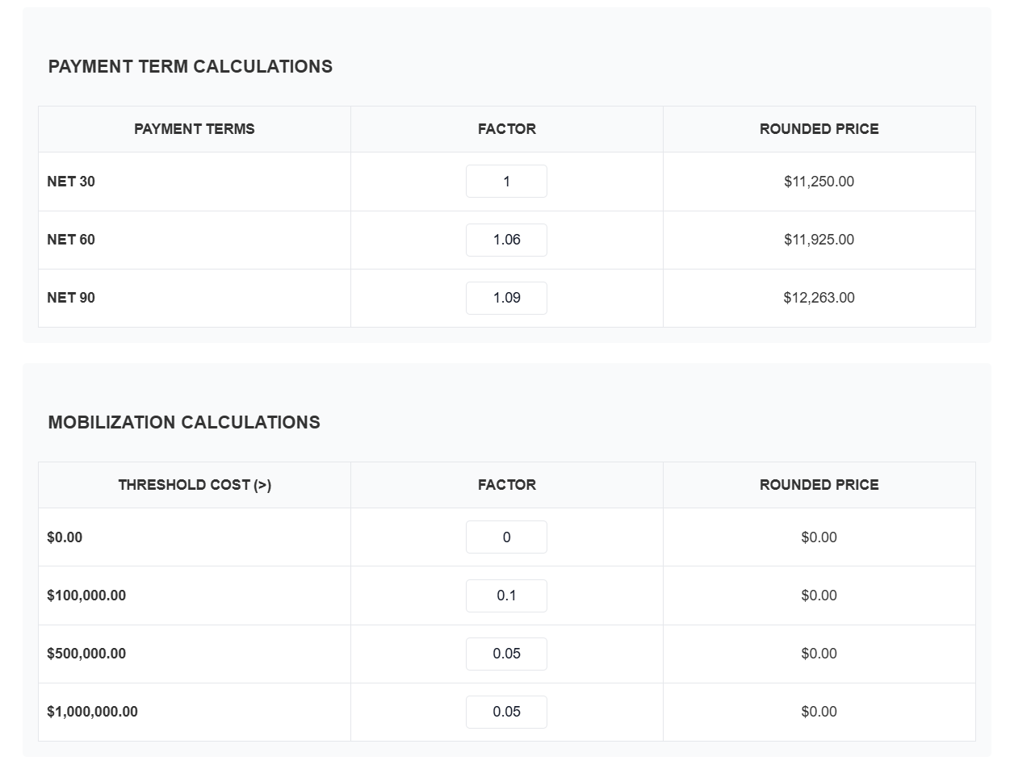

Summary (no editing)
- We would like a new print-out / viewable table: customer facing schedule of values table. This is what “SOV” stands for. This will be a table with the ITEM, the QUANTITY, the SOV ITEM PRICE, and a new column: the “SOV TOTAL PRICE” which will be the SOV ITEM Price multiplied by the QUANTITY. It is a very simple table that lets our customer know how we will be progress billing them (where applicable).

Travel Page
Below is what Claude made for us in place of our existing travel table.

Vehicle Travel
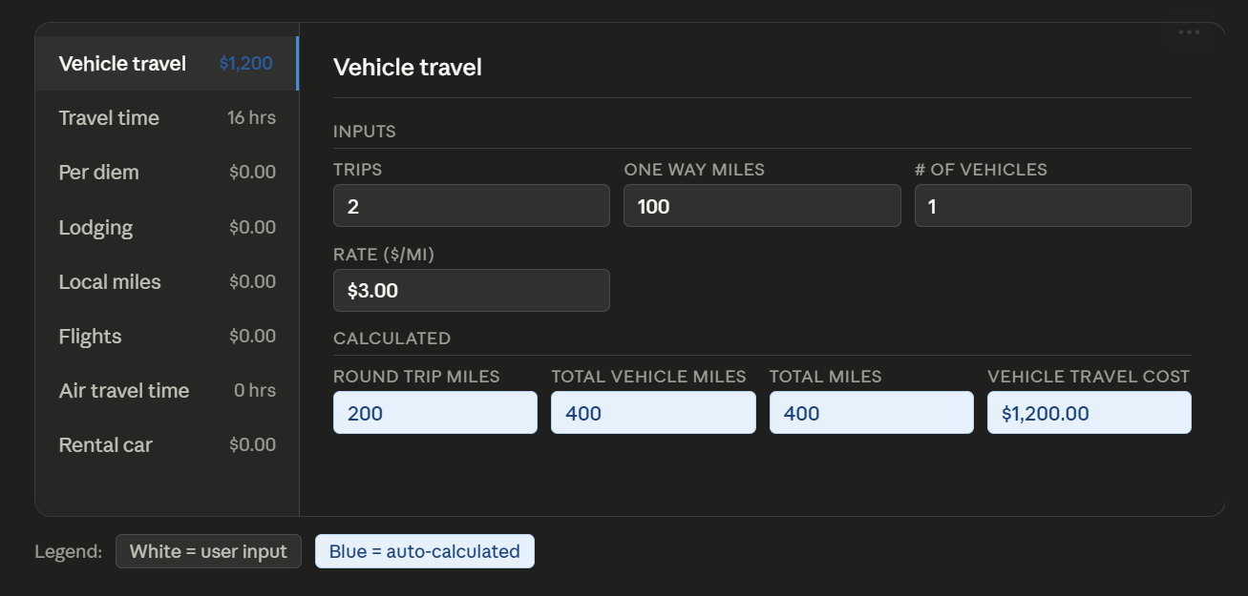
- We would like to be able to plan multiple trips within this vehicle travel page from multiple locations so the one-way miles might be different between trips or may have a different number of vehicles. So we please configure this where we can add multiple and the total vehicle cost will sum together when all is said and done.

Travel Time
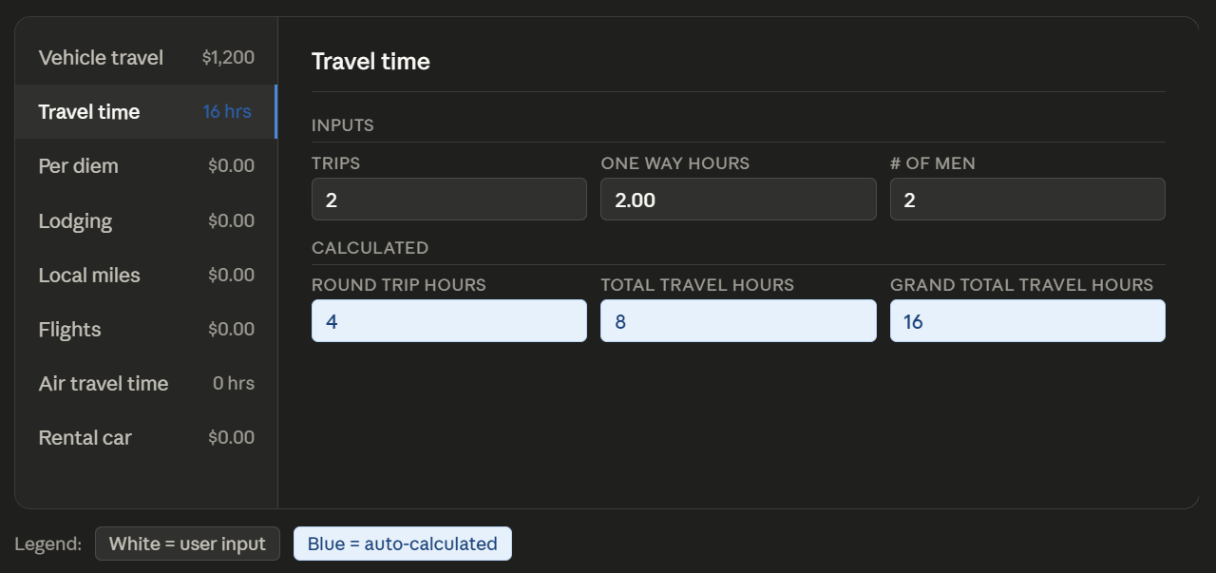
- CRITICAL CHANGE: we

Per Diem
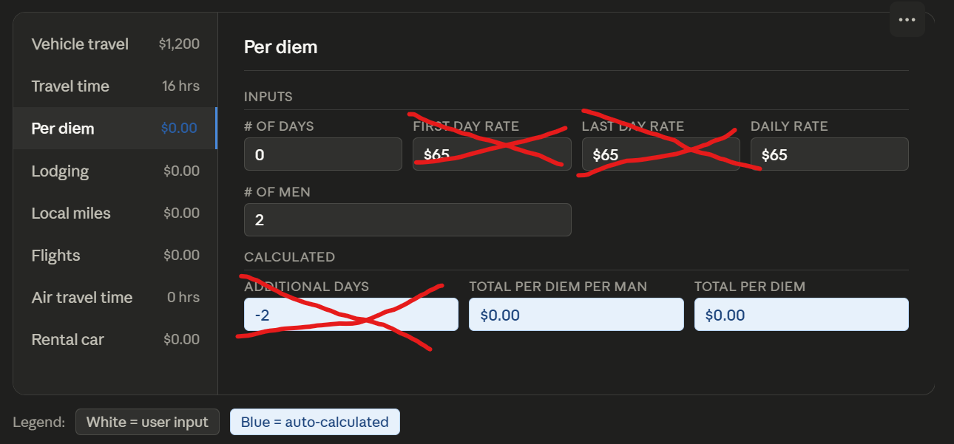
(please do not include the marked out fields)

Lodging
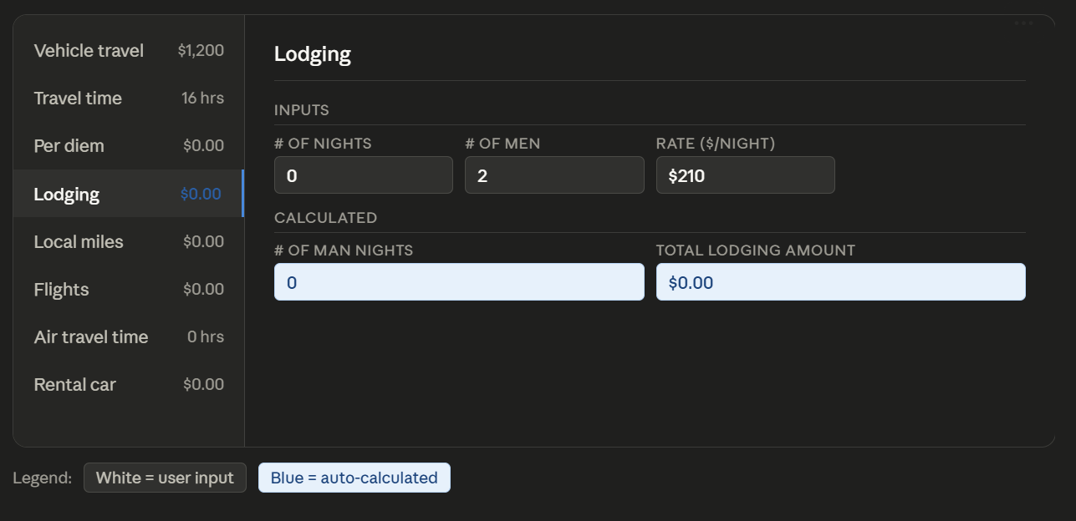

Local Miles
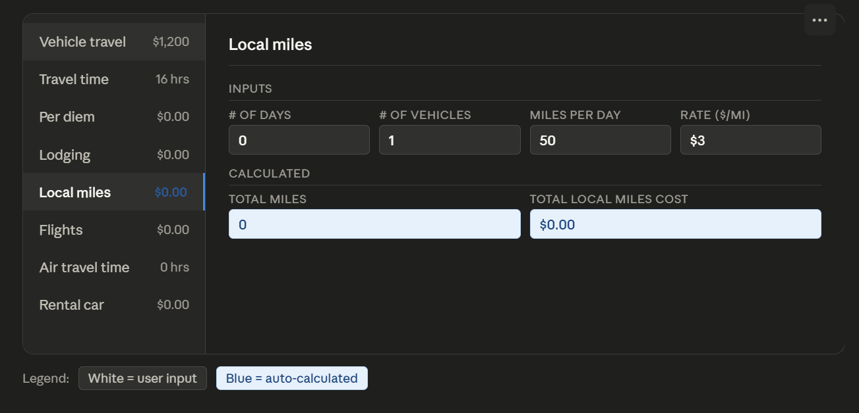

Flights
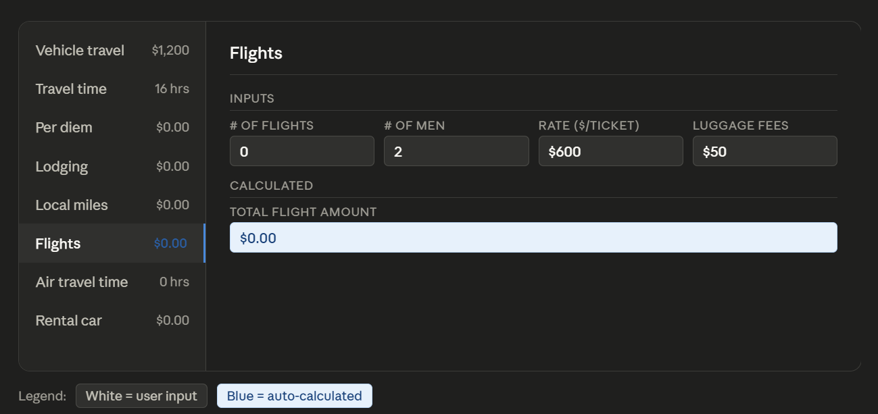

Air Travel Time
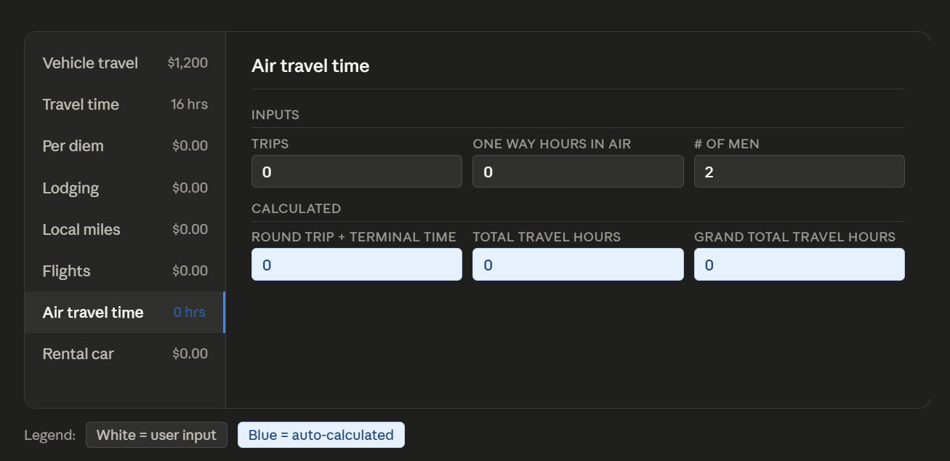

Rental Car
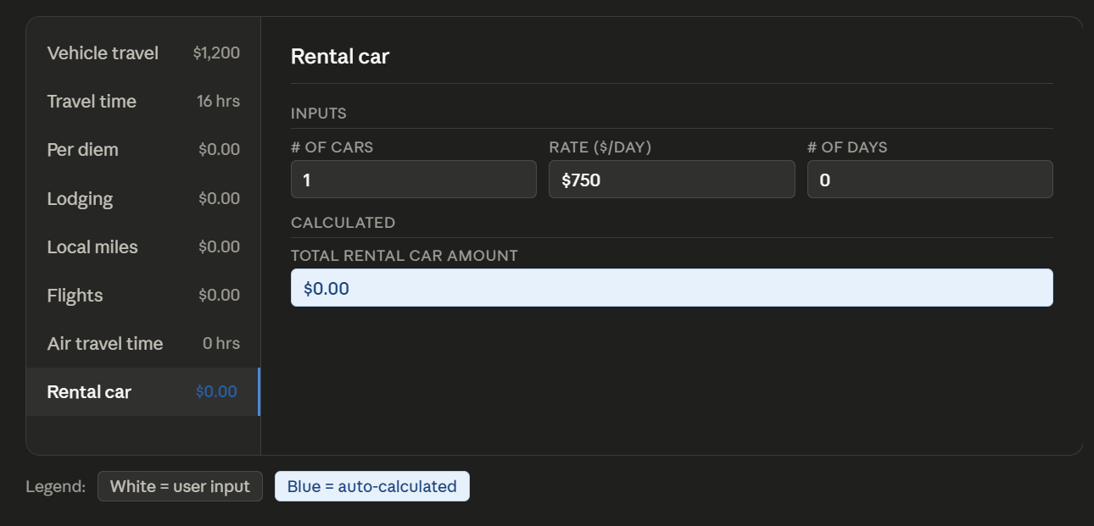
- This is a slight change from how we have been performing rental car calculations but I think it is an improvement. We should move to a daily rate for the rental car instead of what we are doing currently which is just a rate and a number. Please make this change. We will likely set the rental car daily rate around $100/day which is slightly above the average for an SUV from an airport.

Logistics & Pricing
Logistics & Pricing
https://claude.ai/share/48cb2f74-5587-431f-aff0-7310240a68b3

- Several modifications can be made to this section. First we will no longer be needing the expense total since we are no longer recording it in our estimates, We would also like to ditch the cards and s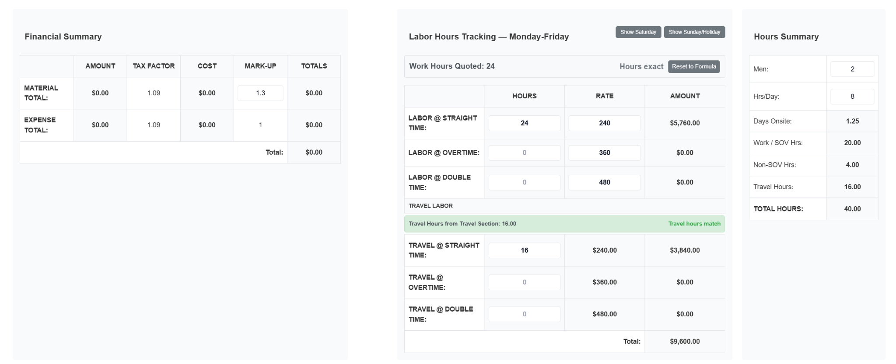witch to a more tabular view, and also split each section into its own side nav section.

Hours Summary
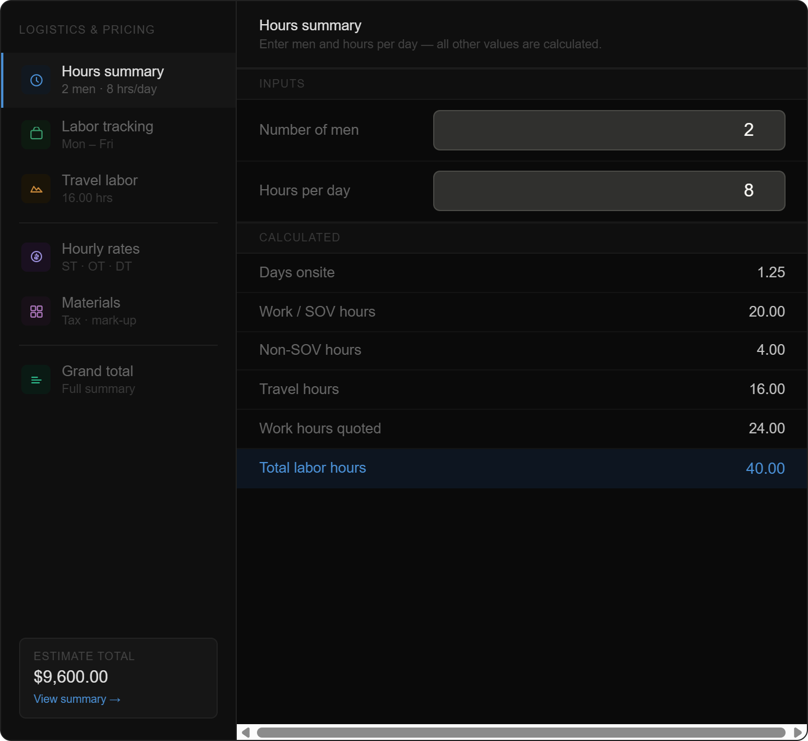

Labor Tracking
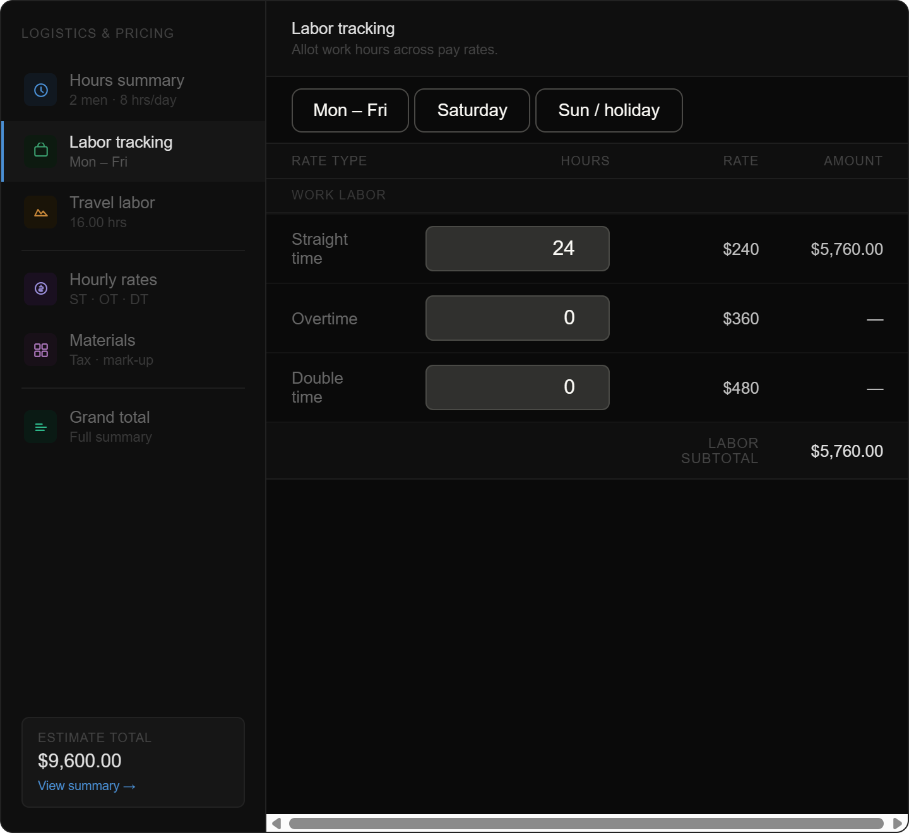

Travel Labor
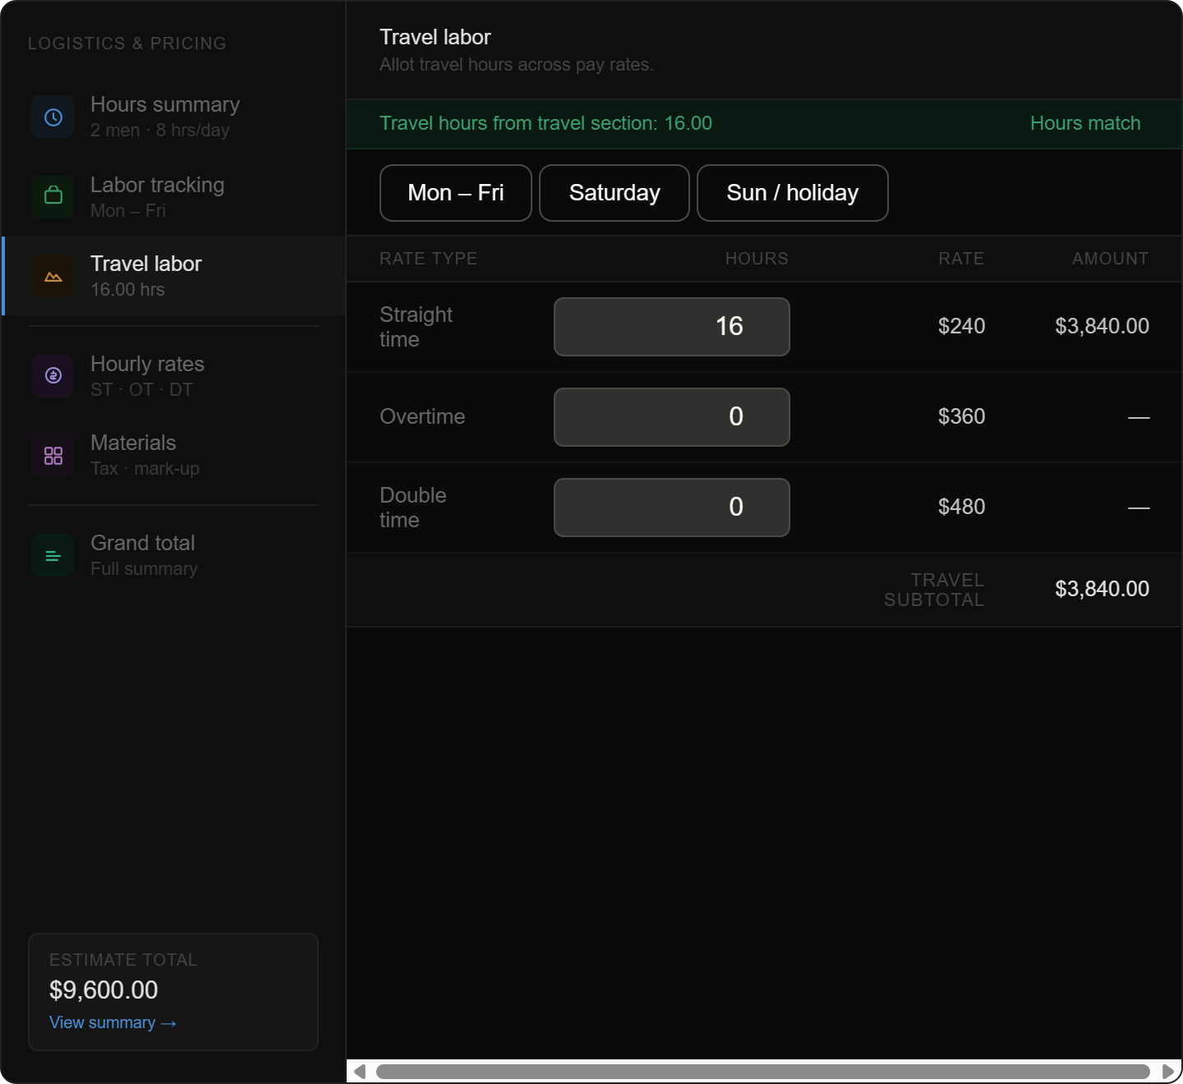
Hourly Rates
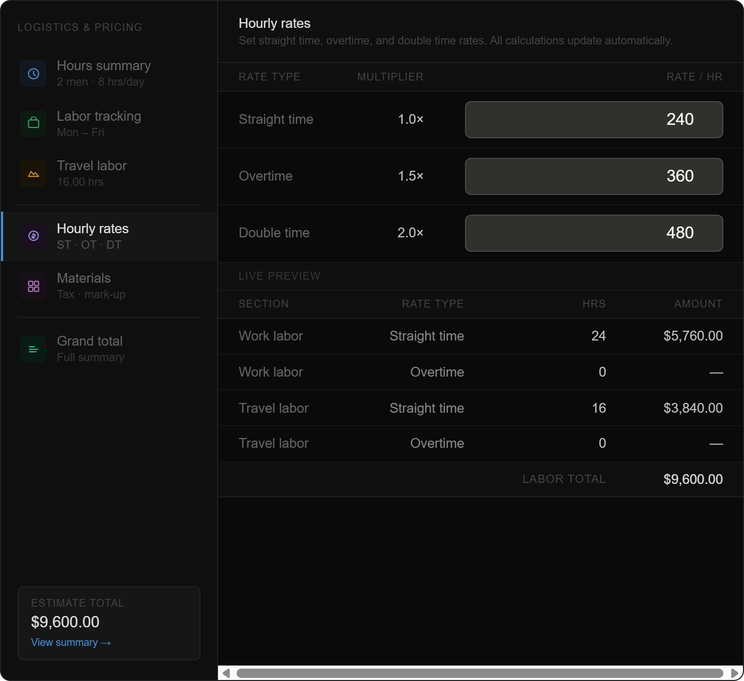

Materials
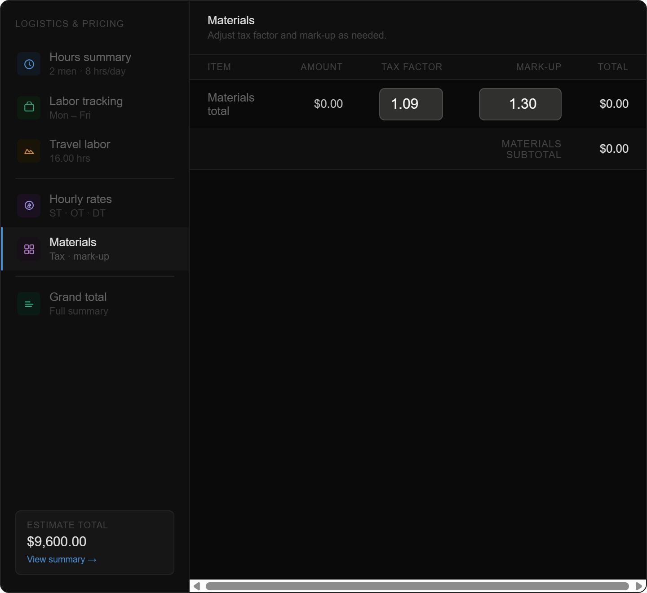

Summary
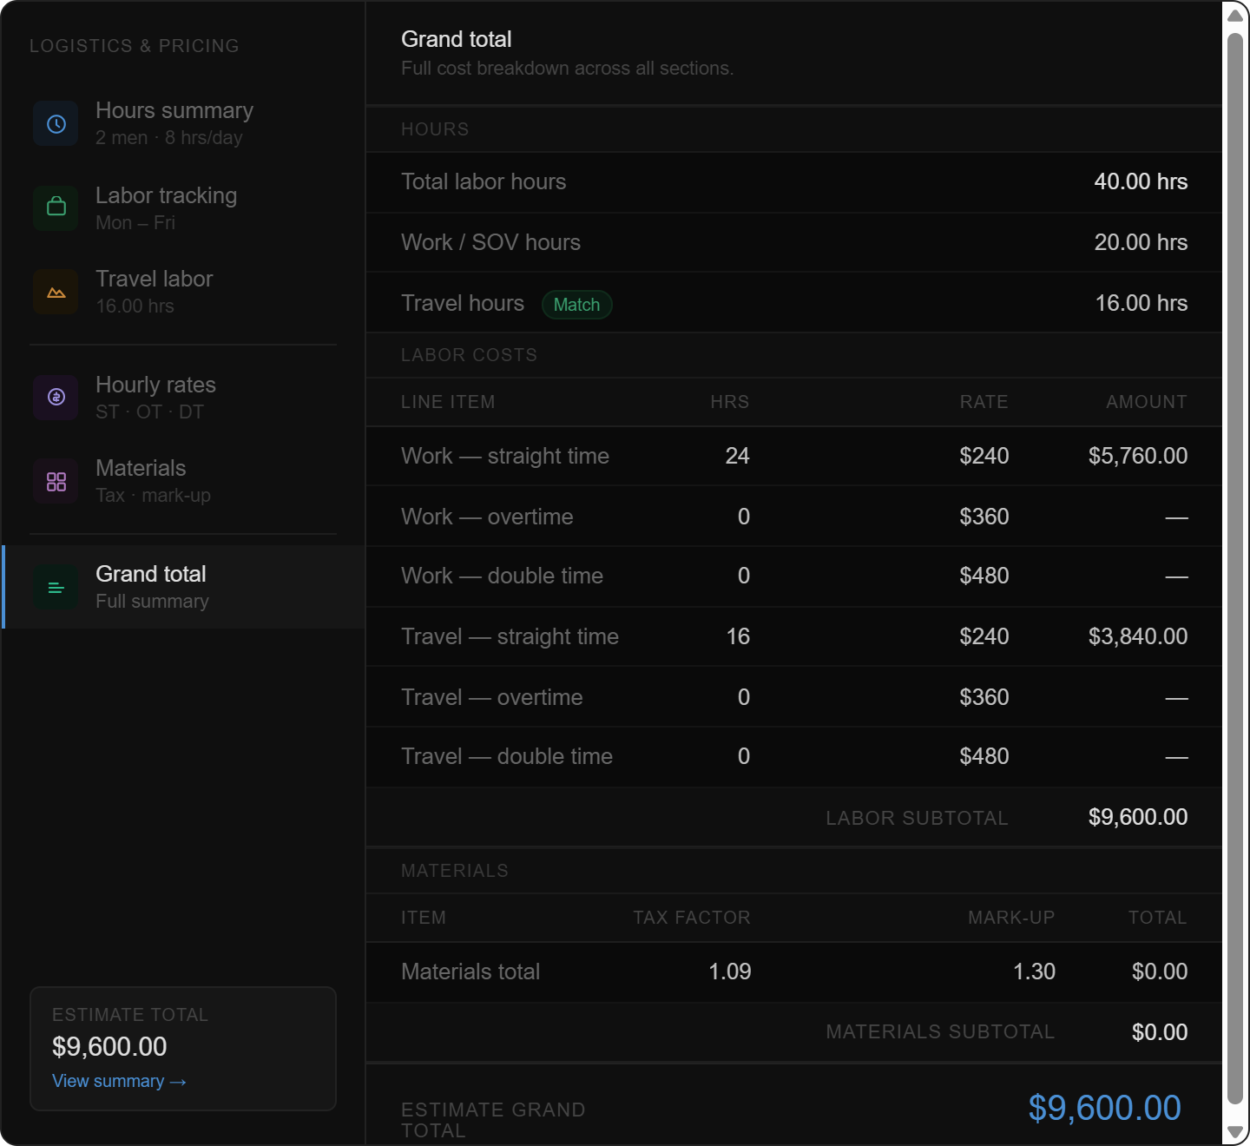

Summary Table

Summary Page Overview

Schedule of Values
- We would like a new print-out / viewable table: customer facing schedule of values table. This is what “SOV” stands for. This will be a table with the ITEM, the QUANTITY, the SOV ITEM PRICE, and a new column: the “SOV TOTAL PRICE” which will be the SOV ITEM Price multiplied by the QUANTITY. It is a very simple table that lets our customer know how we will be progress billing them (where applicable).

